|  |  |
| --- | --- |
| Car Battery Recycling: Why It's Important & How You Can Help | Firestone  Complete Auto Care  battery restoration  A Reverse Logistics Model using AnyLogic | Isaiah Sarria, Jack Levitt, Randy Koliha, Susan Nunez |

# Introduction

The AnyLogic model represents costs associated with a reverse logistics process that involves two parts. First: collecting, storing, and transporting defective Electrical Vehicle Batteries. Second: the recycling and remanufacturing of those defective Electrical Vehicle Batteries to convert them into a completely restored Electrical Vehicle Battery.

Using optimization and efficiency factors of both of those parts, we want to see how these costs are impacted.

# Parameters

The two parameters, Optimized Logistics and Efficiency of the Recovery Process, negatively affect all the costs. The Efficiency of the Recovery Process has an inverse relationship specifically with the Remanufacturing Price, Recycling Cost, and the Recycling Fee dynamic variables. The more efficient the recovery process is, the costs associated with recovery (remanufacturing and recycling) are reduced. Optimized Logistics works the same way with its inverse relationship between costs associated with logistics: Transportation Cost, Collection Cost, and Storage Cost. The more optimized the logistics of the supply chain of collecting, storing, and transporting is, the less expensive those processes are.

# Dynamic Variables

The model consists of seven dynamic variables: Collection Cost, Transportation Cost, Storage Costs, Recycling Cost, Recycling Fee, Remanufacturing Price, and together they accumulate into the dynamic variable, Total Cost of Electric Vehicle Battery Recovery. We define the Collection Cost as the price of the logistics component that requires labor to physically gather all defective batteries. The Transportation Cost is what must be paid to then move these heavy batteries to a storage facility which then has its own costs to hold the batteries until the restoration process, Storage Cost. The Transportation Cost also includes the cost of taking the batteries to the recycling plant. Those three costs are affected by how optimized the logistics of them are and they contribute to the Total Cost of Electric Vehicle Battery Recovery dynamic variable. The Recycling Fee is paid every time a new batch of electric batteries is taken to start in the recycling process which then affects the total Recycling Cost of extracting the useful components of the defective battery. These scavenged parts can then be moved into the remanufacturing process in the plant where the new electric vehicle batteries are manufactured, and the price of this process is the Remanufacturing Price dynamic variable. As a result, the Recycling and remanufacturing costs that affected by the efficiency of recovery process sum into the other half of the Total Cost of Electric Battery Recovery.

# Model

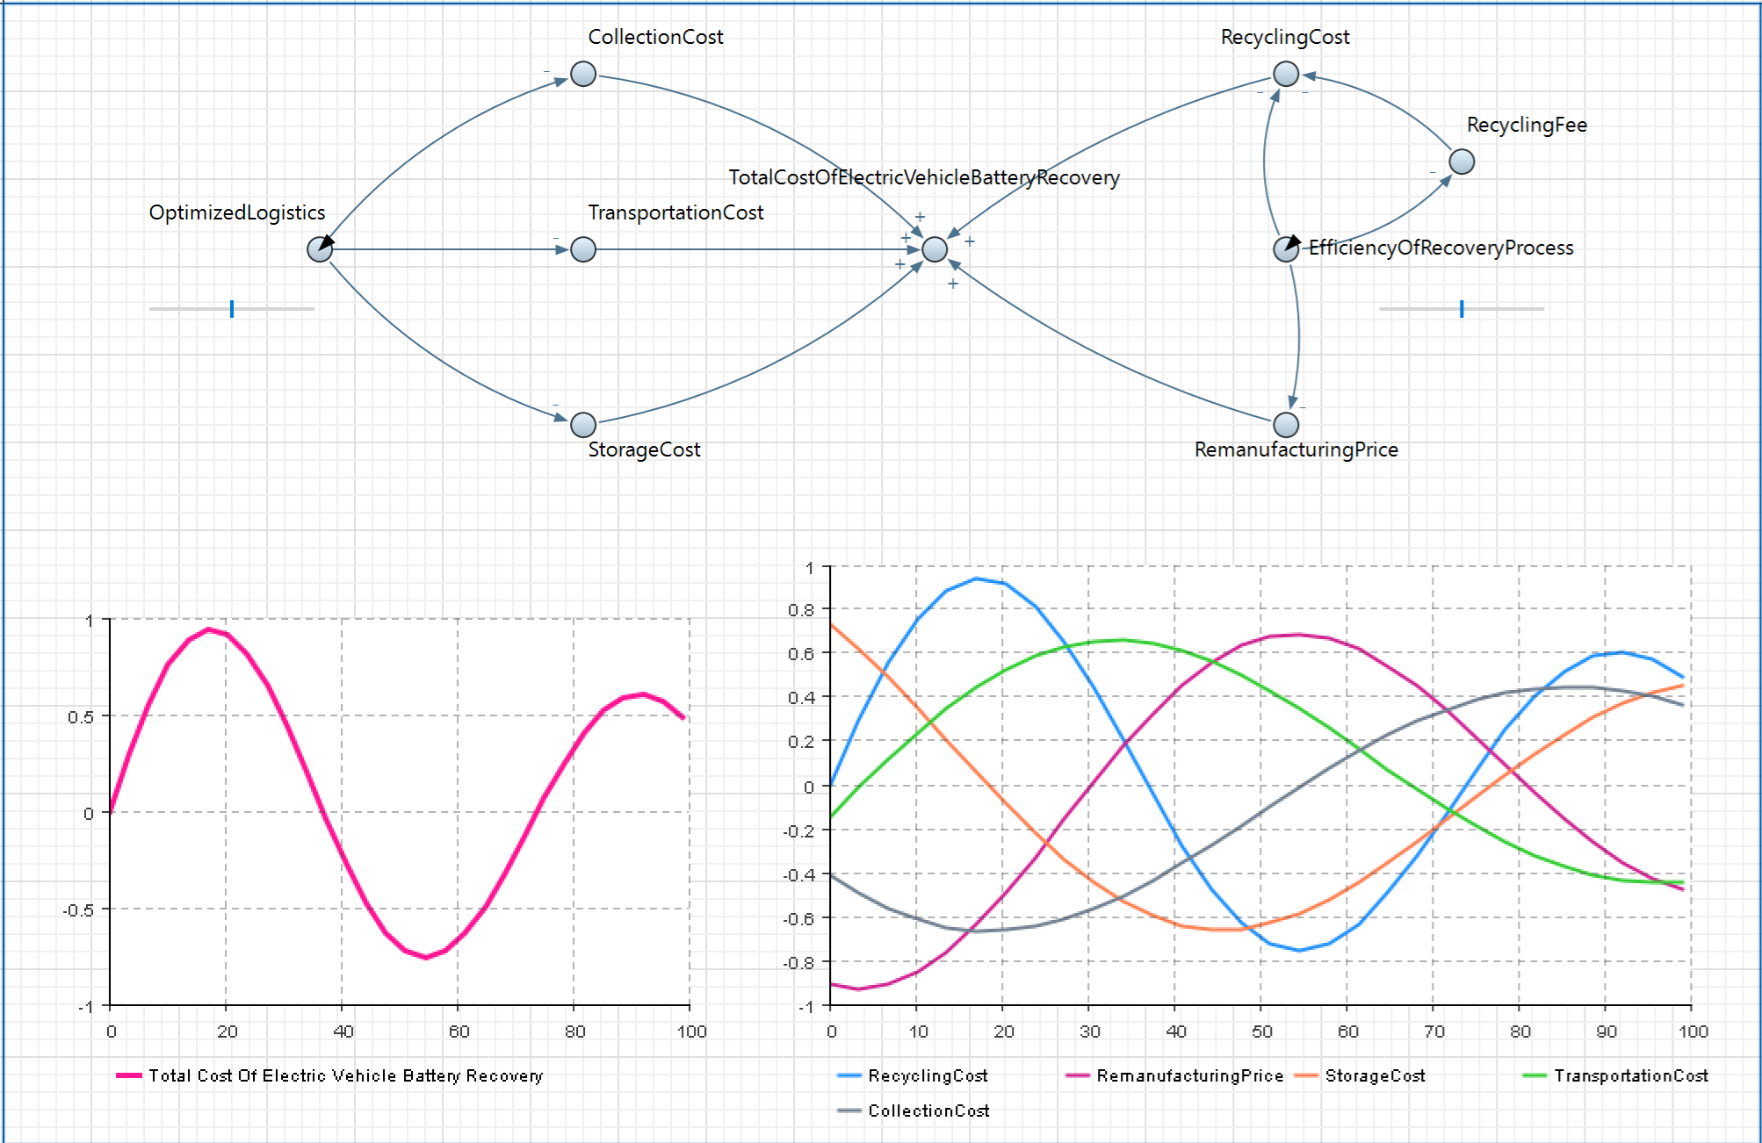

Here is a broad view of the full model. We created a dynamic model that gets the total cost of electric vehicle battery recovery. This also encompasses other costs such as collection cost, transportation cost, storage cost, recycling cost, remanufacturing cost. We also have outside factors that affect the outside costs that ultimately affect the total cost in the middle of the model. The rates that affect the outside cost of the total are the optimized logistics rate and efficiency of recovery process rate. These rates can be controlled by sliders that will change the rate from 0.01 to 1. The closer the slider is to 1 means it is more efficient. On the bottom of our dynamic model, we have two graphs. The graph on the left shows us how total price changes over time when sliders have been adjusted. In this graph both sliders affect the line. In the graph on the right, it graphs each individual cost, which can be affected by the slider that the costs share a side with. For instance, recycling cost and remanufacturing cost are only affected by the rates slider for efficiency of recovery process. Later In the report the effect of the rates will be further discussed.

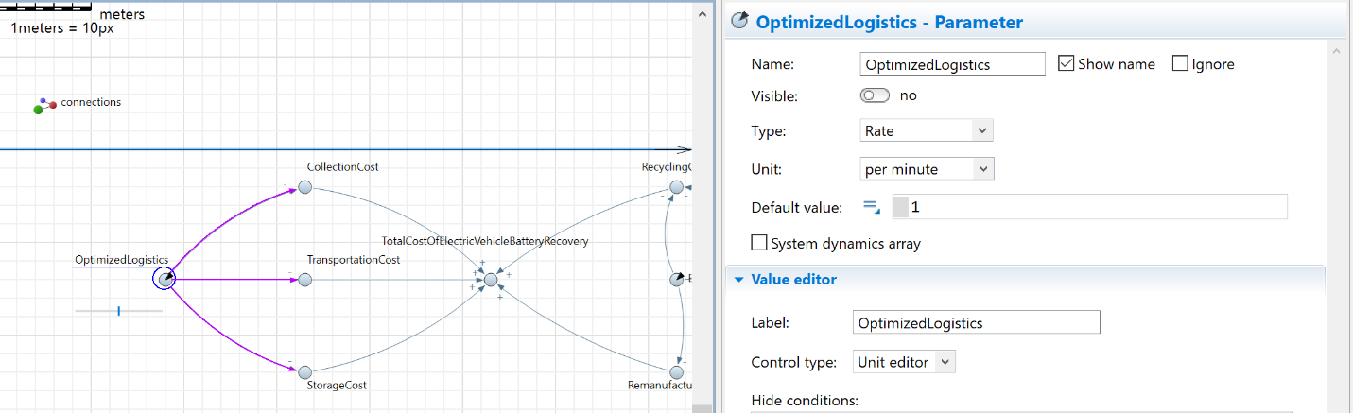

Here in this portion of the model we can see that parameter optimized logistics is set as a rate which affects the costs collection cost, transportation cost, and storage cost. This parameter is attached to a slider that can affect what value is passed to it. That value then gets passed to the equation of the dynamic variables that will be later discussed.

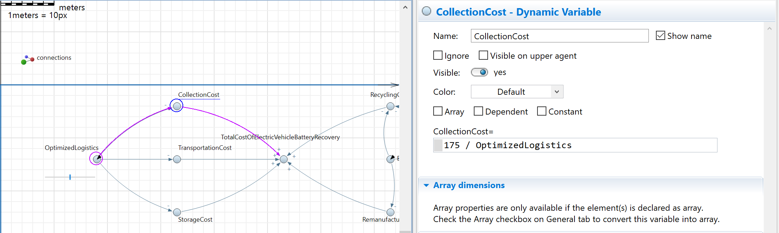

Here a dynamic variable collection cost is selected. The cost of this cost is 175 and is divided by optimized logistics so that the relationship of the slider will be the lowest cost when divided my 1 and as the efficiency of the slider goes down the price of the cost goes up. Note that this cost will only be affected by the parameter and associated slider on the left, optimized logistics.

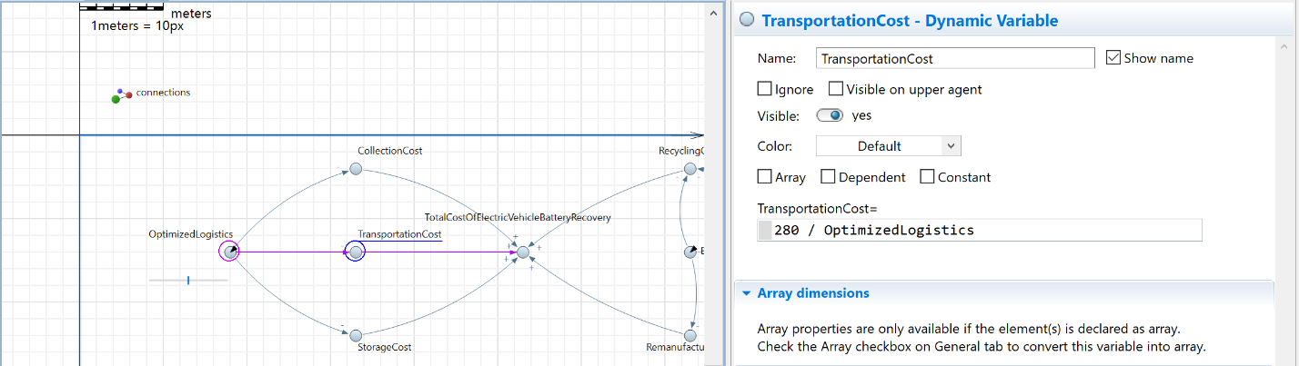

Here in the selection of this dynamic variable the cost of this cost was set to 280. Like the previous cost this is affected by parameter optimized logistics and associated slider. The same logic of the division equation works the same here.

Here in the selection of this dynamic variable the cost of this cost was set to 300. Like the previous cost this is affected by parameter optimized logistics and associated slider. The same logic of the division equation works the same here.

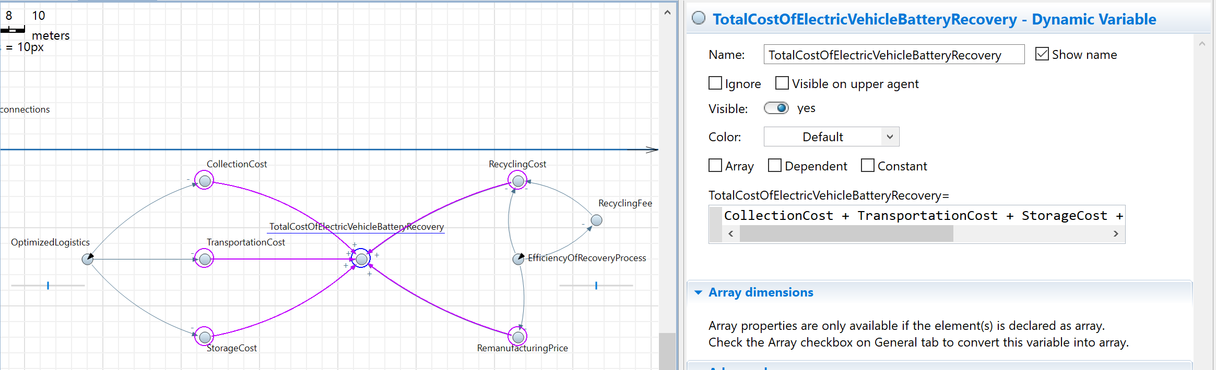

Here is the dynamic variable total cost of electric vehicle battery recovery. This is the cost of all the costs combined. This simply adds collection cost, transportation cost, storage cost, recycling cost, remanufacturing cost. This dynamic variable is tied to the graph on the left of the model and will track the total cost over time. Note that both parameters ultimately affect this dynamic variable.

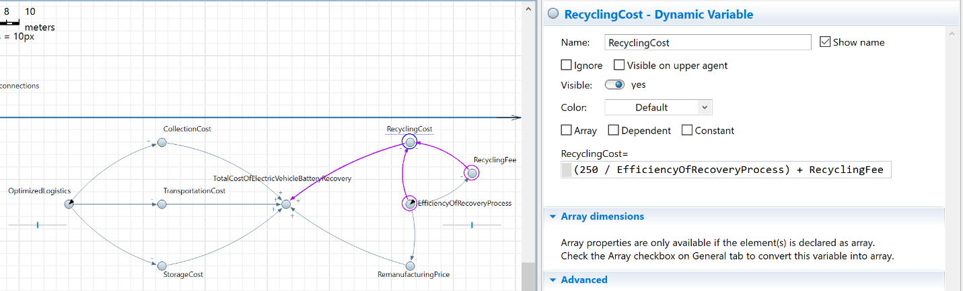

Here the recycling cost is seen. The cost of this cost is different from what has been seen thus far. In this cost it is set at 250 dollars on top of the recycling fee. Because efficiency of recovery process and recycling fee affect this dynamic variable 250 was divided for the parameter and the dynamic variable was added. This cost will be only affected by the efficiency of the recovery process and its associated slider. As the slider approaches 1 the cost goes down and vice versa is true.

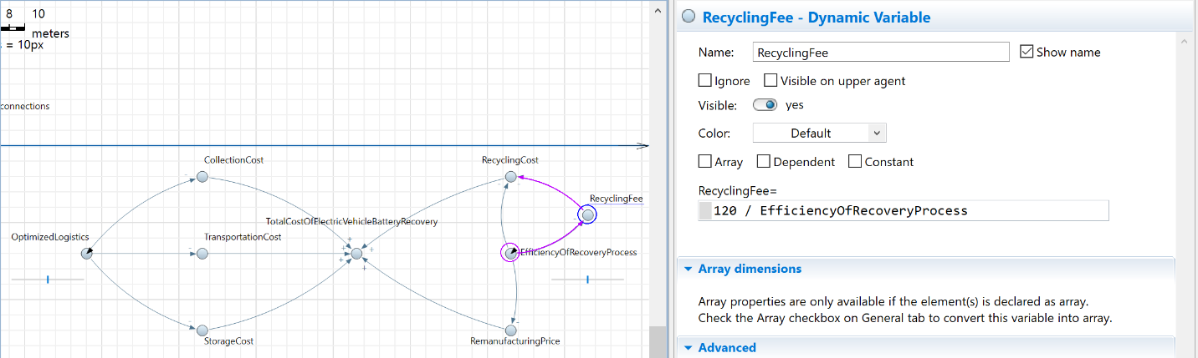

Here is the recycling fee dynamic variable. The fee was set at a cost of 120. This is divided by the parameter efficiency of recovery process. This dynamic variable follows the same logic as the dynamic variables on the right of the model. The cost is divided by the rate so that when efficiency goes down the price goes up and vice versa.

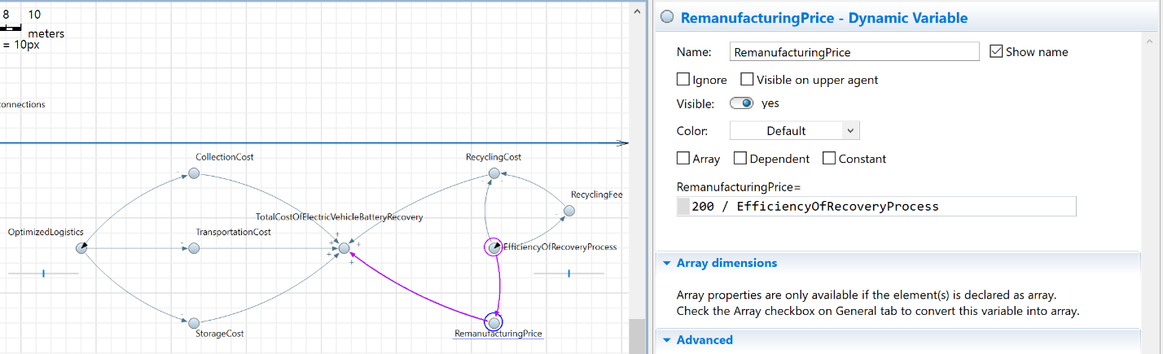

Here is the remanufacturing price dynamic variable. The fee was set at a cost of 200. This is divided by the parameter efficiency of recovery process. This dynamic variable follows the same logic as the dynamic variables on the right of the model. The cost is divided by the rate so that when efficiency goes down the price goes up and vice versa.

Here we have the parameter efficiency of recovery process. It is set as a rate and defaults to 1 for the simulation of the live model. The associated slider has a range of 0.01 to 1. When the slider approaches 0 the price of the costs attached to this parameter goes up.

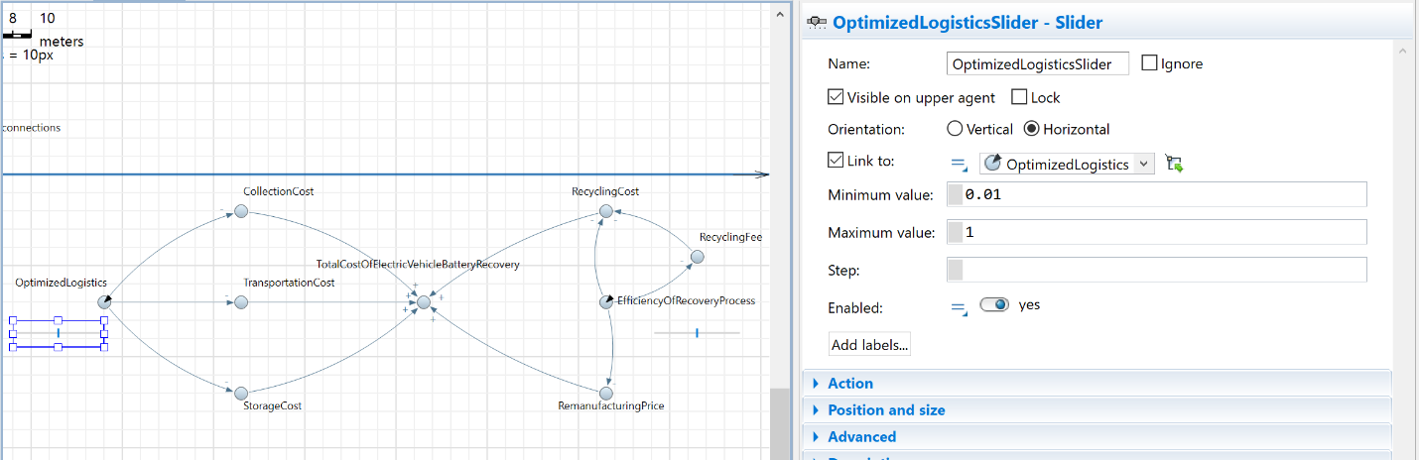

Here the sliders that are attached to the parameters on each side will change the value when the live model is active. The range of the values is 0.01 to 1. Once the sliders approach zero the associated cost on each side goes up and vice versa also occurs, this makes more visual sense when the 3d model is active. In the models you see total cost affected by both sliders because it’s all costs added. In the right graph the sliders only affect their respective costs associated with them.

# Results

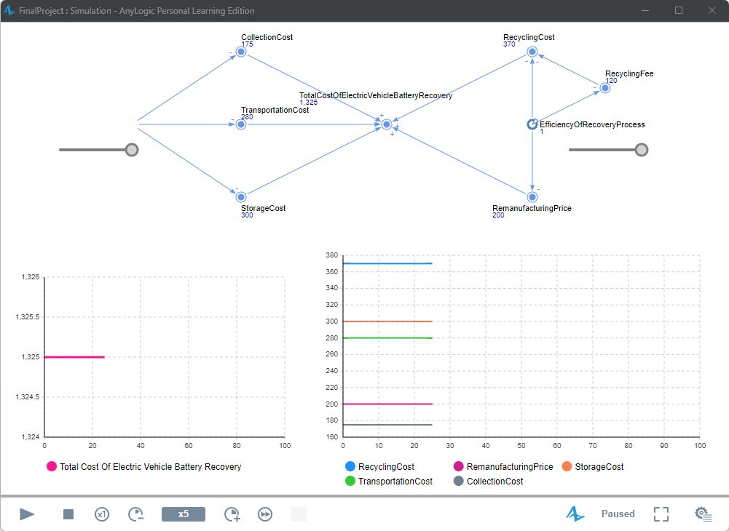

These graphs state this is when the sliders are both at 1 meaning that it is at max efficiency. This brings all the costs and total costs to the lowest possible level.

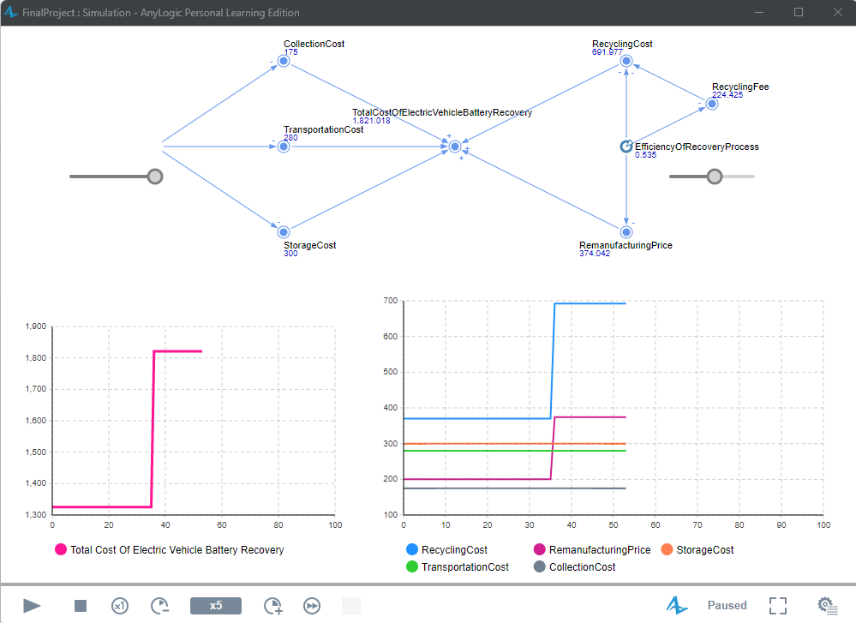

These graphs show when the slider on the right is reduced. This means the efficiency has dropped making the costs increase for efficiency of recovery processes respective costs. This also bring the total cost up but only by the aggregated costs on the right. When the slider is put back toward 1 the cost drops.

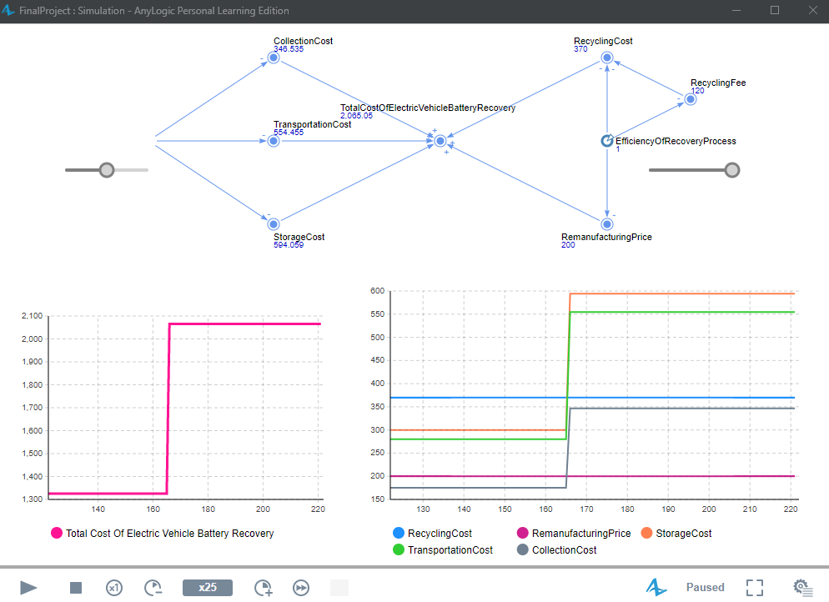

These graphs show when the slider on the left is reduced. This means efficiency has dropped making the costs increase for optimized logistics respective costs. This also brings the total cost up but only by the aggregated costs on the left. When the slider is put back toward 1 the cost drops.

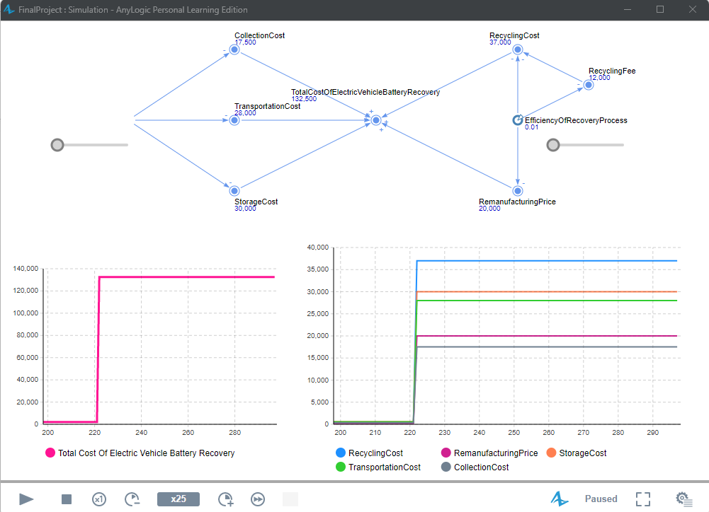

Here in these graphs both sliders for were shifted all the way to the left. What this means is that their value for the rate is the closest to zero that they can be. A limiter was set so that the efficiency did not actually become zero. Instead, the minimum value is 0.01, this rate value in relation to the dynamic variables makes the total cost and individual costs rise. In short if both rates on each end of the model are fully reduced, the costs will rise to their maximum possible value.

# Conclusion

All the costs in the model contribute to the total costs of restoring electric car batteries. The optimization of the logistics process and the efficiency of the recovery process both reduce the total cost. The graphs show how they independently affect the costs. For example, if the logistics process is completely optimized and the recovery process efficiency is at 50%, then the costs of defective battery collection, transportation, and its storage is as low as possible whereas the costs associated with remanufacturing and recycling the battery is also reduced, but it can still go lower. The total costs will reflect both of those results, as per the graph displaying the total cost of the electric vehicle battery recovery reverse logistics process.